Detecting Building Defects Using VGG16 with IBM Cloud

**Table of content:**

|  |  |
| --- | --- |
| **1.** | **INTRODUCTION** |
| **2.** | **LITERATURE SURVEY** |
| **3.** | **THEORITICAL ANALYSIS** |
| **4.** | **EXPREIMENTAL INVESTIGATIONS** |
| **5.** | **FLOW CHART** |
| **6.** | **RESULT** |
| **7.** | **ADVANTAGES** |
| **8.** | **APPLICATIONS** |
| **9.** | **CONCLUSION** |
| **10.** | **FUTURE SCOPE** |
| **11.** | **BIBLIOGRAPHY** |
| **12.** | **APPENDIX** |

**1.Introduction**

**Overview:**

In this project detecting building defects such as cracks, flakes, and roof defects, We are using CNN pre-trained model VGG16 to analyze the type of building defect on the given parameters. The objective of the project is to build an application to detect the type of building defect.

Detection of defects including cracks and flakes on the wall surfaces in high-rise buildings is a crucial task of buildings maintenance. If left undetected and untreated, these defects can significantly affect the structural integrity and the aesthetic aspect of buildings, Time and cost-effective methods of building condition survey are of practicing need for the building owners and maintenance agencies to replace the time- and labor-consuming approach of the manual survey.

**Purpose:**

Clients are increasingly looking for fast and effective means to quickly and frequently survey and communicate the condition of their buildings so that essential repairs and maintenance work can be done in a proactive and timely manner before it becomes too dangerous and expensive.

**2. literature Survey**

**Existing problem:**

Traditional methods commonly comprise of engaging building surveyors to undertake a condition assessment which involves a lengthy site inspection to produce a systematic recording of the physical condition of the building elements, including cost estimates of immediate and projected long-term costs of renewal, repair, and maintenance of the building.

This is time consuming and also not economical

**Proposed solution:**

The user interacts with the UI (User Interface) to open the integrated webcam.

The video frames are captured and analyzed by the model which is integrated with the flask application.Once the model analyses the video frames, the prediction is showcased on the UI and OpenCV window

**3.** **Theoretical Analysis**

**Block Diagram:**

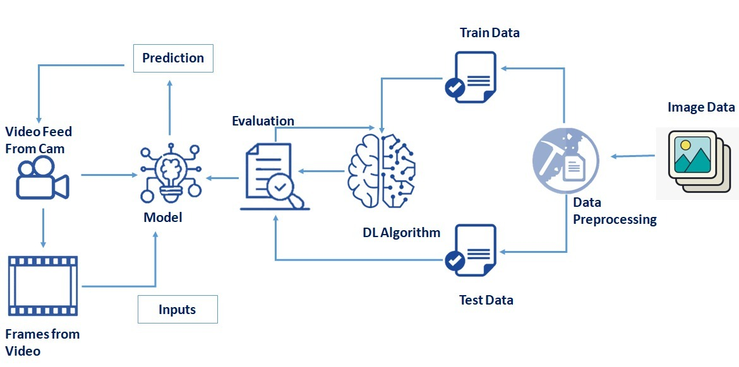

**Hardware/Software Designing:**

we require the following softwares : Jupyter notebook ; for image preprocessing, testing and training the data Flask web application and spyder, IBM Cloud account

Some basics like cnn model development and python coding are also required

**4.Experimental Investigations**

**Abstract:**

Clients are increasingly looking for fast and effective means to quickly and frequently survey and communicate the condition of their buildings so that essential repairs and maintenance work can be done in a proactive and timely manner before it becomes too dangerous and expensive. Traditional methods for this type of work commonly comprise of engaging building surveyors to undertake a condition assessment which involves a lengthy site inspection to produce a systematic recording of the physical condition of the building elements, including cost estimates of immediate and projected long-term costs of renewal, repair and maintenance of the building. Current asset condition assessment procedures are extensively time consuming, laborious, and expensive and pose health and safety threats to surveyors, particularly at height and roof levels which are difficult to access.

**original image data:**

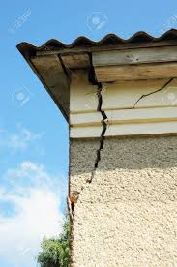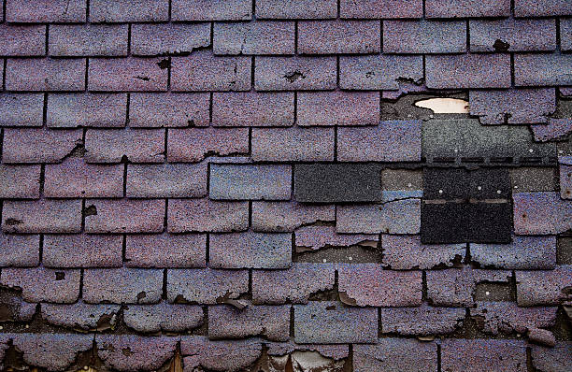

Crack Roof

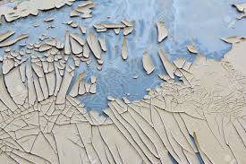

Flakes

**5. Flow Chart**

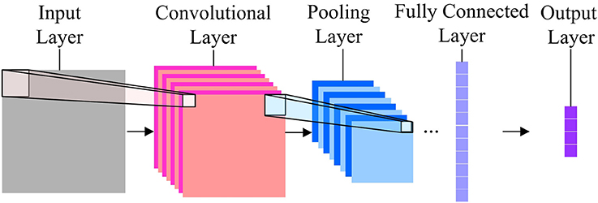

Fig1

**6. Performance Analysis**

Given a domain:

D = X, P(X) ,

(1) Then X is the feature map, and P(X) is the probability distribution, X = {x1, · · · , xn} and {x1, · · · , xn} ∈ X then the learning task T is defined as: T = Y, yˆ = P(Y X)

(2) where Y is the set of all labels, and yˆ is the prediction function. The training data is represented by the pairs xi , yi where xi ∈ X, yi ∈ Y. Suppose DS denotes the source domain and DT denotes the target domain, then the source domain data can be presented as:DS = n xS1 , yS1 , · · · , (xSn , ySn ) o ,

(3) where xSi ∈ XS is the given input data, and ySi ∈ YS is the corresponding label. The target domain DT can also be represented in the same way: DT = n xT1 , yT1 , · · · , (xTn, yTn ) o ,

(4) where xTi ∈ XT is the given input data, and yTi ∈ YT is the corresponding label. In almost all real-life applications, the number of data instances in the target domain is significantly less than those in the source domain that is: 0 ≤ nT nS

(5) Definition For a given source domain DS and a learning task TS, with target domain DT and a learning task TT, then transfer learning is the use of knowledge in DS and TS to improve the learning of the prediction function yˆT in DT, given that DS , DT and TS , TT [60]. Since any domain is defined by the pair: D = X, P(X) , (6) where X is the feature map, and P(X) is the probability distribution, X = {x1, · · · , xn} ∈ X, then according to the definition, if DS , DT: =⇒ XS , XT and PS(X) , PT(X) (7) Sensors 2019, 19, 3556 7 of 22 Similarly, if a task is defined by: T = Y, yˆ = P(Y X) (8) where Y is the set of all labels, and yˆ is the prediction function, then by definition, if TS , TT: =⇒ YS , YT and yˆ S , yˆT

**7. Result**

Finally, as a result for this project we will predict the cracks, flakes, roof.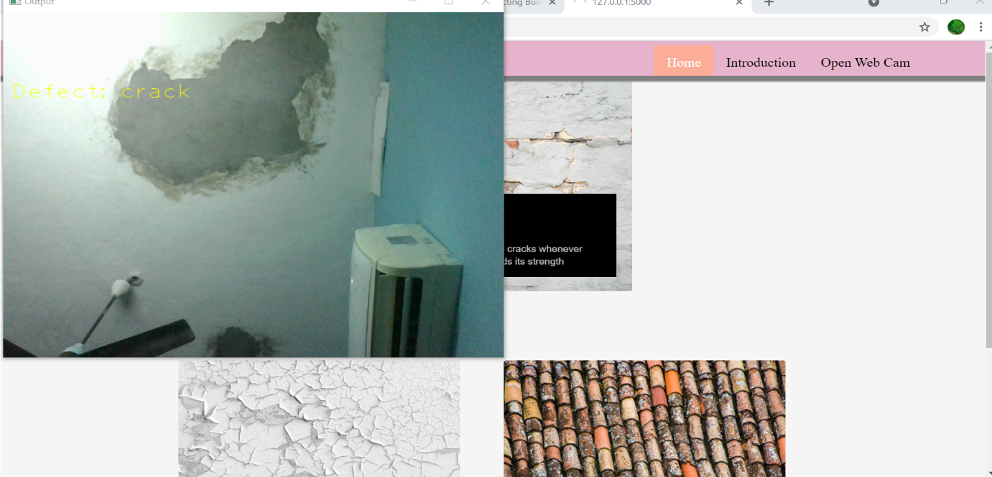

In the above figure we can see the detection of crack.

**8. Advantages**

* Time saving
* Economical
* Efficient

**9. Applications**

* Archeology
* Analyze the building state
* To know quality is construction

**10. Conclusion and Future Scope**

For our classification problem, we applied a fine-tuning transfer learning to a VGG-16 network pre-trained on ImageNet. A total of 2,622,224 × 224 images were used as our dataset. Out of the 2622 images, a total 1890 images used for training data: mould (534 images), stain (449), paint deterioration (411) and normal (496). In order to obtain sufficient robustness, we applied different augmentation techniques to generate larger dataset. For the validation set, a 20% of the training data (382 images) was randomly chosen. After 10 epochs, the network recorded an accuracy of 97.83% with 0.0572 loss on the training set and 98.86% with 0.042 loss on the validation. The robustness of our network was evaluated on a separate set of 732 images, 183 images for each class. The evaluation test showed a consistent overall accuracy of 87.50% and 90% of images containing mould correctly classified, 82% for images containing deterioration, 89% for images containing stain and 99% for normal images.

To address the localisation problem, we integrated the CAM technique which was able to locate defects with high precision. The overall performance of the proposed network has shown high reliability and robustness in classifying and localising defects. The main challenge during this work was the availability of large labelled datasets which can be used to train a network for this type of problem. To overcome this obstacle, we used image augmentation techniques to generate synthetic data for a largely enough dataset to train our model.

**12.Bibliography**

1. Mohseni, H.; Setunge, S.; Zhang, G.M.; Wakefield, R. In Condition monitoring and condition aggregation for optimised decision making in management of buildings. Appl. Mech. Mater. 2013, 438, 1719–1725. [CrossRef]

2. Agdas, D.; Rice, J.A.; Martinez, J.R.; Lasa, I.R. Comparison of visual inspection and structural-health monitoring as bridge condition assessment methods. J. Perform. Constr. Facil. 2015, 30, 04015049. [CrossRef]

3. Shamshirband, S.; Mosavi, A.; Rabczuk, T. Particle swarm optimization model to predict scour depth around bridge pier. arXiv 2019, arXiv:1906.08863.

4. Zhang, Y.; Anderson, N.; Bland, S.; Nutt, S.; Jursich, G.; Joshi, S. All-printed strain sensors: Building blocks of the aircraft structural health monitoring system. Sens. Actuators A Phys. 2017, 253, 165–172. [CrossRef].

5. Noel, A.B.; Abdaoui, A.; Elfouly, T.; Ahmed, M.H.; Badawy, A.; Shehata, M.S. Structural health monitoring using wireless sensor networks: A comprehensive survey. IEEE Commun. Surv. Tutor. 2017, 19, 1403–1423